Source https://deluxeiceland.is/luxury-tours/private-south-shore/
__________________________________________________________

Private Icelandic South Shore Day Tour
__________________________________________________________
★★★★★ 4.8/5 30 reviews

Add to wishlist ♡

__________________________________________________________

10-11 hours | From €410 per person

🏕  Image | 🏕  Image | 🏕  Image | 🏕  Image | 🏕  Image | 🏕  Image

__________________________________________________________
About This Tour
Discover the stunning South Shore of Iceland on this exclusive Private Day Tour. With your own guide, explore the iconic Seljalandsfoss and Skógafoss waterfalls, the famous Reynisfjara black sand beach, and more. This tour is perfect for those seeking to experience Iceland’s natural beauty in a personalized and intimate setting.
Your journey includes pickup and drop-off in Reykjavik, ensuring a convenient and seamless experience. Bring your sense of adventure as you explore one of Iceland’s most spectacular coastlines!
__________________________________________________________
What’s Waiting for You
- Duration: 10 - 11 hours
- Group Size: Private group, ideal for families, couples, or small groups
- Accommodation: Not applicable (Day tour)
- Languages Available: English
- Private Guided Tour: Tailored experience with your own expert guide
- Transportation: Luxury vehicle with Free Wi-Fi and bottled Icelandic water on board
- Season: Available year-round
__________________________________________________________

Check Dates & Availability

Select participants: (Age 99 and younger) - 1 +

Choose date:
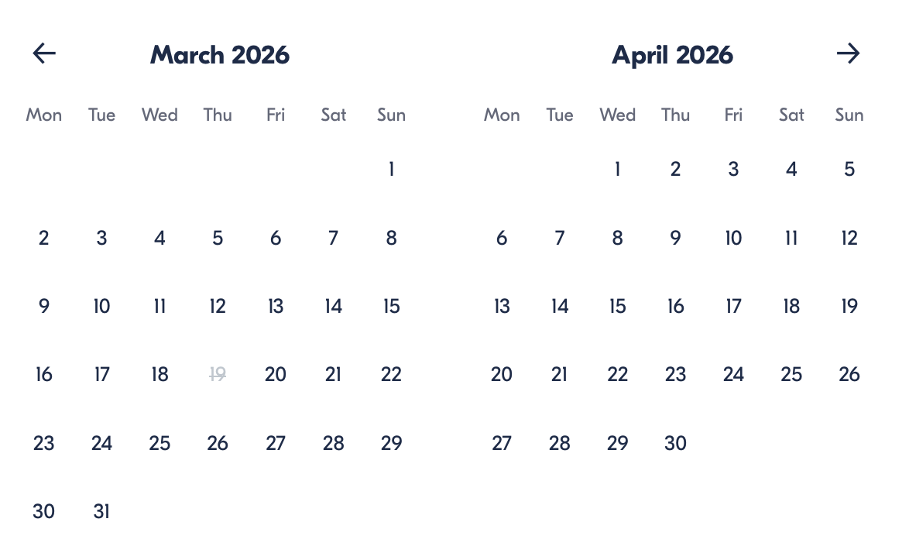

Check Availability

opens:

Participants: 2 March 16, 2026

Private Icelandic South Shore Day Tour

- Duration: 10-11 hours
- Offered in: English
- Starts at: 10:30 AM

Cancellation:

- More than two weeks prior to arrival: 40% Credit / 60% Refunded
- Less than two weeks prior to arrival: 50% Credit / 50% Refunded
- Less than 72 hours prior to arrival: No refund and no credit

Price breakdown: 2 Participants x €410

Total: €820

The total price includes all taxes and fees.

Add to cart Book now

__________________________________________________________
Tour Features
- Seljalandsfoss Waterfall: Walk behind one of Iceland’s most iconic waterfalls.
- Reynisfjara Black Sand Beach: Explore the dramatic cliffs and sea stacks.
- Skógafoss Waterfall: Get close to one of the largest waterfalls in Iceland.
- Private Vehicle: Travel comfortably in a luxury vehicle with Wi-Fi and water on board.
__________________________________________________________
Detailed Itinerary
- Day 1 – Explore the South Shore
Start your day with a morning pickup from Reykjavik. Your guide will take you on a scenic 1.5-hour drive to Seljalandsfoss, where you can walk behind the waterfall for a truly magical view. Continue your journey to Reynisfjara, Iceland’s famous black sand beach. Marvel at the Reynisdrangar Cliffs and sea stacks, and feel the power of the waves.
Next, visit Skógafoss, one of Iceland's largest and most powerful waterfalls, with a drop of 60 meters. Walk right up to the base for an incredible experience and photo opportunities. Afterward, your guide will take you back to Reykjavik, with plenty of time for stops along the way.
__________________________________________________________
Included in Price
- English-speaking local guide for the duration of the tour
- Luxury vehicle with Free Wi-Fi and bottled Icelandic water
- Private tour tailored to your preferences
- Pick-up & drop-off from Reykjavik
- All taxes and fees – no hidden charges
__________________________________________________________
Not Included
- Meals (Lunches and dinners are not included)
- International flights
__________________________________________________________

Cancellation Policy
For 5 or Fewer Participants:
- More than 2 weeks before arrival: 40% Credit / 60% Refund
- Less than 2 weeks before arrival: 50% Credit / 50% Refund
- Less than 72 hours before arrival: No refund or credit
For 6 or More Participants:
- More than 4 weeks before arrival: 40% Credit / 60% Refund
- Less than 4 weeks before arrival: 80% Credit / 20% Refund
- Less than 2 weeks before arrival: No refund or credit
Changes in the number of participants may increase the price per person. We recommend comprehensive travel insurance.
Weather-Related Cancellations:
If activities are canceled due to weather, they will be fully refunded. Itineraries may change based on conditions, with safety as the top priority.
Refund Processing:
Refunds are processed within 15 days after the tour ends.
__________________________________________________________
What Our Clients Are Saying

Overall rating  4.8/5  ★★★★★  Based on 30 reviews | Review summary  Guide 4.5/5  Transportation 4.6/5  Service 4.7/5  Organisation 4.5/5

Filter  - All traveller types  - Couples  - Group of friends  - Families  By star rating  - All star ratings  - 5 stars  - 4 stars  - 3 stars  - 2 stars  - 1 star | Search reviews (e.g., guide)  Sort by:  - Top picks  - Latest reviews  - Best ratings  - Lowest ratings
__________________________________________________________
★★★★★
Maria – Spain
An amazing day exploring Iceland’s South Shore! The waterfalls and beaches were breathtaking. Our guide was knowledgeable and made the whole experience unforgettable.

★★★★★
Oliver – United Kingdom
A perfect day trip! From walking behind Seljalandsfoss to seeing the black sand beach, this tour had it all. Highly recommend for anyone looking to explore Iceland’s nature!

★★★★☆
Julie – France
Excellente excursion! Les cascades et la plage de sable noir étaient magnifiques. Notre guide était top, mais nous aurions aimé un peu plus de temps à Skógafoss.

See more reviews
__________________________________________________________

Meta tags

Page - Private Icelandic South Shore Day Tour

Title: Private Icelandic South Shore Day Tour | Travellio Global

Description: Experience the stunning beauty of Iceland’s South Shore on a private day tour. Visit iconic waterfalls, black sand beaches, and dramatic landscapes with your own expert guide. Ideal for those seeking an intimate, personalized Iceland adventure.

H1 - Private Icelandic South Shore Day Tour
__________________________________________________________

